Supreme Committee for Delivery & Legacy
Golf Cars Management System (GGCMS ) Product Requirements Document (PRD)
Logistics Services

Version 1.0
Dated : 9 February 2026

Project: SC LOG - Golf Cart Management System (GCMS )
Document Version: 2.3
Date: February 1, 2026
Status: Draft for Implementation

Table of Contents
1. Introduction 4
1.1 Background 4
1.2 Objective 4
1.3 Scope of Work 5
2. Functional Requirements & User Roles 6
2.1 Detailed Definition of User Roles 6
3. Users & Access levels 7
3.1 Core Functional Modules & System Logic 8
4. GCMS Business Rules 10
4.1 General Usage Policies 10
4.2 FA’s Users Master Data & Trigrams 10
5. Non-Functional Requirements 11
6. Project Management & Execution 12
7. Photos and prototypes and examples 12

1. Introduction

1.1 Background
The Golf Cart Management System (GCMS ) is a mission-critical digital platform commissioned by the Supreme Committee for Delivery & Legacy (SC) Logistics to oversee the end-to-end lifecycle of the Golf cars fleet during high-profile stadium operations. Operating across primary venues—including Al Bayt (ABS), Lusail (LUS), Ahmad Bin Ali (AAS), Al Thumama (ATS), Education City (ECS), and Khalifa (KIS) and other tournament sites—the system serves as a centralized hub for real-time dispatching, live condition tracking, and stringent asset allocation.
Given the high demand and limited availability of these vehicles, the GCMS is designed to ensure that fare allocation and distribution aligns strictly with the pre-approved tournament Allocation Plan.
The system provides a unified web-based interface for Venue Logistics Managers (VLM), the Logistics Coordination Centre (LCC), and Venue Operations Centers (VOC) and the maintenance contractor to monitor dedicated venue inventory, including Cargo carts for equipment logistics, 4-seater and 6-seater passenger vehicles, and high-specification utility units.

1.2 Objective
The primary objective of the GCMS is to deploy a scalable, cloud-based operational framework that digitizes the end-to-end management life cycle of the golf cart fleet.
This solution aims to streamline the handover, incident reporting, and handback procedures while enforcing rigorous operator accountability. By providing real-time usage metrics and maintenance status alerts, the system empowers the LCC / VOC and VLM to optimize asset distribution and ensure that all vehicles remain in optimal mechanical condition for match and non-match day activities. The platform will deliver comprehensive data visualization, enabling data-driven decision-making for tournament-wide fleet utilization and logistical support.

1.3 Scope of Work
The GCMS implementation encompasses the following core operational boundaries and requirements:
- Comprehensive Fleet Tracking: Each stadium and venue will have a unique set of golf car fleet that the system administrator will input and feed into the system as a stadium asset, to be managed throughout the stadium tournament duration.
- Supplier Handover & Initial Inspection: System Administrators and Venue Logistics Managers (VLM) must perform a formal condition report upon receipt of vehicles from the supplier. This protocol requires a comprehensive inspection to ensure all stadium fleet units are received in ideal mechanical condition, with batteries fully functional and no visible body damage. Verification must include a check of charging cables and keys for every unit before vehicles are delivered to their designated charging stations at the venue.
- Allocation Compliance: Enforcement of the tournament Allocation Plan, ensuring carts are utilized exclusively by pre-approved Functional Areas (FAs) as defined in the allocation plan.
- Asset Digital Registry: A centralized, high-integrity database of all fleet units. This registry will catalog every vehicle by its unique Club Cart Number and Unit Type (Cargo, 4 or 6 seater Passenger, or Accessibility). It will track critical hardware components including GC identifier numbers and Charging Cable assignments. Furthermore, the registry will manage and monitor the VAPS (Vehicle Access Parking Permit) status for each unit, ensuring that regulatory compliance and access rights are transparent and audited in real-time.
- Accountability & Liability Framework: Digitization of handover forms to capture digital signatures from FA’s focal point staff and authorized contractors, ensuring that liability for damages and repair costs is clearly defined in case of incident reported.
- Monitoring and reporting : Provision of real-time monitoring capabilities for the LCC and VOC to ensure stadium-level fleet operations are meeting the overarching tournament requirements.

2. Functional Requirements & User Roles

2.1 Detailed Definition of User Roles
To ensure operational security and accountability per LOG.PO.02, the system shall support the following user personas:
- System Administrator / Venue Logistics Manager (SC LOG / VLM):
  - Scope: Full administrative access across all stadiums, sites, and venues.
  - Responsibilities: Initial fleet registration and bulk data seeding; management of the master FA staff registry (users) and authorized maintenance contractor accounts; configuration of UX/UI tournament-specific branding (including key tag color-coding and windshield labeling).
  - Authority: Performs formal supplier handovers (receiving the fleet), records detailed unit metadata, validates incident/damage reports, and accesses the main reporting dashboard to monitor utilization and extract audit-ready exports.
- Logistics Coordination Centre (LCC) & Venue Operations Center (VOC):
  - Scope: Monitoring and Reporting Oversight.
  - Responsibilities: High-level access to the "Operations Dashboard" to view fleet status across all stadiums simultaneously.
  - View-Only Rights: Can view live car conditions, track current operators (users) linked to specific units, and monitor the volume of cars currently operated vs. those in standby or charging. This role ensures that LCC and VOC can make rapid redeployment decisions if a venue experiences a shortage.

- FA Focal Point / Standard User:
  - Scope: Personnel from authorized Functional Areas (e.g., MOB, SPS, LOG).
  - Responsibilities: Responsible for his assigned units only. This includes checking cars in/out cars, reporting incidents or mechanical failures instantly, and managing physical car and key custody.

- Authorized Maintenance Contractor:
  - Scope: Service provider personnel responsible for technical upkeep and repairs.
  - Responsibilities: Access to the "Maintenance Hub" to view real-time damage logs and mechanical reports submitted by users.
  - Workflow: Upon completion of a repair, the contractor reports back via the system, documenting the fix and confirming the vehicle is in ideal usable condition. Once validated, they update the unit status to "Ready" and return the vehicle to the active usable cars operational fleet and the vehicle to the designated venue charging station.

3. Users & Access levels

Stakeholder | Access Level | Primary Need
System Admin | Super User (Full Control) | System Governance: Full authority to initialize stadiums, register GC Fleet assets, and manage system themes.  User Management: Create accounts and map specific Functional Areas (FAs) to dedicated vehicles.  Data Oversight: Perform data overrides and export comprehensive analytic reports.
User | Venue-Specific Access and cars assigned to him | Operational Execution: Access is restricted to assigned stadiums and specific fleet sets.  Lifecycle Management: Conducts digital "Check-in" (receiving), logs real-time operational issues/incidents, and completes "Check-out" (hand-back) protocols.
LCC & VOC | Read-Only Dashboard and extract reports | High-level view of fleet condition and current usage reports condition report and Realtime tracking
Maintenance | reports & records | To access the maintenance reports and report back once the inspection and report are concluded and the car are fully functional and back to the pool

3.1 Core Functional Modules & System Logic
ID | Module Name | Priority | Detailed Description | User Role
FR-01 | Unified Authentication | Critical | Secure manual login via Accreditation ID. Logic must validate the user against the master registry and stadium assignment. Personalized UI displays venue-specific logos and high-priority alerts. | All Users
FR-02 | Master Data & Registry | Critical | Admin crate all users and assignee rolls to them and have a module for bulk record processing of fleet stock, key IDs, VAPS status, and Trigram mapping. Acts as the "Source of Truth" for all system assets. | Admin/ VLM
FR-03 | Supplier Receipt Gateway | High | Gate-keeping module for new fleet arrivals. Requires a detailed multi-point digital inspection (Mechanical, Battery, Body, Cables, Keys) before an asset is "Activated" for stadium use. | Admin / VLM
FR-04 | Venue-Locked Inventory | High | Automatic filtering based on user stadium Trigram (e.g., AAS, ABS). System blocks inter-stadium bookings to ensure local asset control. | Standard User
FR-05 | Shift Check-In (Booking) | High | Mandatory pre-operational checklist. Confirms: Tire pressure, cleanliness, current body condition, and key handover. User must input starting Battery % to track drain rates. | Standard User
FR-06 | Shift Check-Out (Handback) | High | Termination of operational shift. Logs final timestamp and return Battery %. Confirms the unit is stationed at a charging dock. Auto-returns the unit to the "Ready Pool." | Standard User
FR-07 | Instant Incident Report | Medium | Immediate digital capture of issues per LOG.PR.02. Mandatory high-res photo uploads for damages and text descriptions for mechanical failures (e.g., jerking or steering issues). | Standard User
FR-08 | Maintenance Hub | Medium | Technical command interface for contractors. Tracks units flagged for repair. Includes a "Report Fix" module where techs certify mechanical readiness before unit release. | Contractor / VLM
FR-09 | Accountability Sign-off | Medium | Dynamic digital signature capture during Check-In/Out. Signatures link Focal Points and Contractors to joint liability for repair costs. | All Roles
FR-10 | Executive Dashboards | Low | Real-time visualization layer for LCC/VOC. Displays cross-venue fleet health, current active operators, and "Active" vs. "Charging" unit ratios. | LCC / VOC

4. GCMS Business Rules

4.1 General Usage Policies
- Allocation Priority: Strictly prioritized by 1. Health & Safety, 2. Match/Competition Impact, 3. General Operational necessity.
- Speed Restrictions: Vehicles are strictly limited to 10 km/h on fire paths and within stadium perimeters for the safety of spectators and workforce.
- Home Base Rule: Carts must be received and returned to the stadium of origin. Inter-stadium transfers are prohibited per LOG.PO.02.
- Mobilization Standards: Operators assigned to guest mobilization must adhere to tournament-approved disability etiquette and safety guidelines.

4.2 FA’s Users Master Data & Trigrams
- FA Mapping & Account Provisioning: Asset usage and tracking shall be categorized utilizing standard LOC Trigrams (e.g., LOG, MOB, SPS, VUM, GOP) in compliance with the Trigram LOC 20250825 standard. Each Functional Area (FA) is required to nominate a designated Focal Point and submit their credentials to the stadium's LOG Venue Logistics Manager (VLM). The VLM will authorize the creation of a professional system profile linked to the FA's pre-approved tournament fleet allocation. The Focal Point shall act as the primary custodian, assuming full operational and legal accountability for the receipt, handover protocols, and final handback of all assigned units.
- Permit Identification: only cart that needs to operate and access inside and out side the security fence of the stadium must apply for a valid VAPS permit, the status recorded and verified within the GCMS .
4.3 Accountability & Liability
- Contractor Handover: Respective FAs must notify Venue Logistics of authorized contractors. All contractors must sign the digital handover form.
- Joint Liability: Per LOG_PO_02.00, respective FAs remain jointly liable for any repair costs incurred by their designated contractors.

5. Non-Functional Requirements
5.1 System & UI/UX
- Responsive Design: Optimized for mobile browser table’s PC’s.
- Branding Control: Admin capability to customize venue-specific welcome pages and logos.
5.2 Security & Data Integrity
- Secured Operational Database: The system shall maintain a high-security, centralized repository for all tournament-critical data. This secured environment is the single source of truth for exhaustive registries of all Stadiums and Venues, the complete Golf Car Fleet Inventory (Unit numbers, types, key IDs), and comprehensive User & Staff Information (Accreditation IDs, FA assignments). The database ensures that all Maintenance logs and Usage records are permanently archived and protected from unauthorized modification.
- Comprehensive Audit Trails: The system must implement granular logging of every system interaction for complete accountability. This includes:
  - Handover/Handback Logs: Automatic capture of geo-tagged timestamps, user IDs, and car condition snapshots.
  - Incident Reporting Logs: Permanent records of all reported accidents or mechanical failures with linked high-resolution evidence.
  - Maintenance Logsheets: Detailed digital history of all technical repairs, contractor "report back" certifications, and fix validations.
  - Administrative Interactions: Tracking of all backend changes, including bulk Excel data uploads, account provisioning, and asset allocation modifications.

6. Project Management & Execution
6.1 Scope of Service
Implementation of the full software lifecycle: configuration of Database system environment, Power Apps mobile integration, and reporting exports and dashboards .

6.2 Implementation Timeline (Estimated)
- W1: Environment Setup (Database solution architect & Logic Initialization).
- W2-3: Prototype Build: Handover Logic, Inspection Checklists, and Mobile UI.
- W4: Admin Panel Development & Bulk Data Integration.
- W5: User Acceptance Testing (QFF) at Lusail stadium (LUS).
- W6: Final Deployment and VLM Training across all (QFF) venues.

7. Photos and prototypes and examples
7.1 LOC Trigram

Trigram | FA
ADM | Administration Support
HRS | Human Resources
ICT | ICT
WKF | Workforce
COM | Communications
LAN | Languages Services
MER | Media Relations
SHM | Stakeholder Management
CMP | Competition Management
RSV | Referee Services
TSV | Team Services
TFS | Teams Facilities
ACC | Accommodation
AND | Arrivals & Departures
CAT | Catering
FNB | F&B Concessions
GOR | Government Relations
GRE | Guest Relations
LOG | Logistics
MED | Medical
MOB | Mobility
TRA | Travel Services
FNP | Finance & Procurement
CEO | CEO Office
EXP | Experience
GAF | Guest Affairs
BRP | Brand Protection
LGL | Legal
BMR | Broadcasting & Media Rights
CER | Ceremonies & Infotainment
ECR | Events & Community Relations
HOS | Hospitality
LIC | Licensing & Merchandise
MKP | Marketing & Promotion
MRD | Marketing Rights Delivery
SHU | Shukran
SGN | Signage & Dressing
TKT | Ticketing
ACS | Access Management
ACR | Accreditation
BRO | Broadcast Operations
BRS | Broadcast Services
CLW | Cleaning & Waste
SFM | Facility & Stadium Management
GOP | Guest Operations
HSE | Health & Safety
MAP | Maps & Drawing
MEO | Media Operations
OVL | Overlay
PWR | Power
SPS | Spectator Services
SSI | Security Systems Integration
VUM | Venue Management
PLI | Planning & Integration
PMO | Project Management Office
UEX | Experience
SFG | Safeguarding
SUS | Sustainability
HAY | Hayya
SEC | SSOC

7.2 List of pre- approved assigned cars per FA

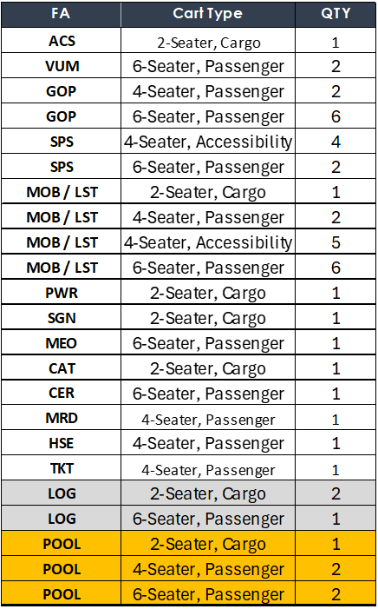

7.3 Key tagging & colour code to identify the car type
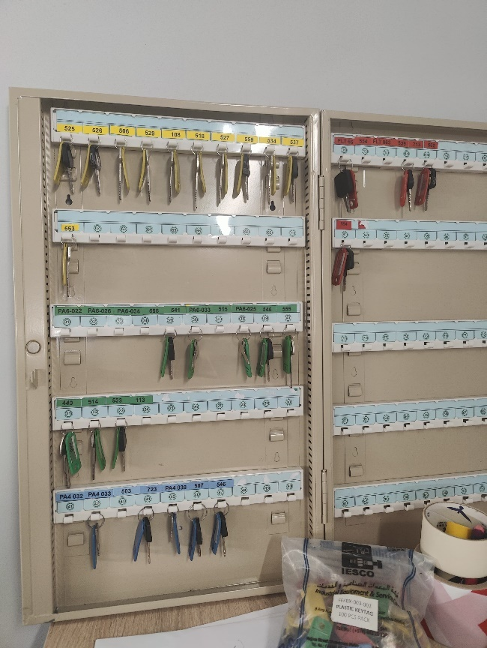
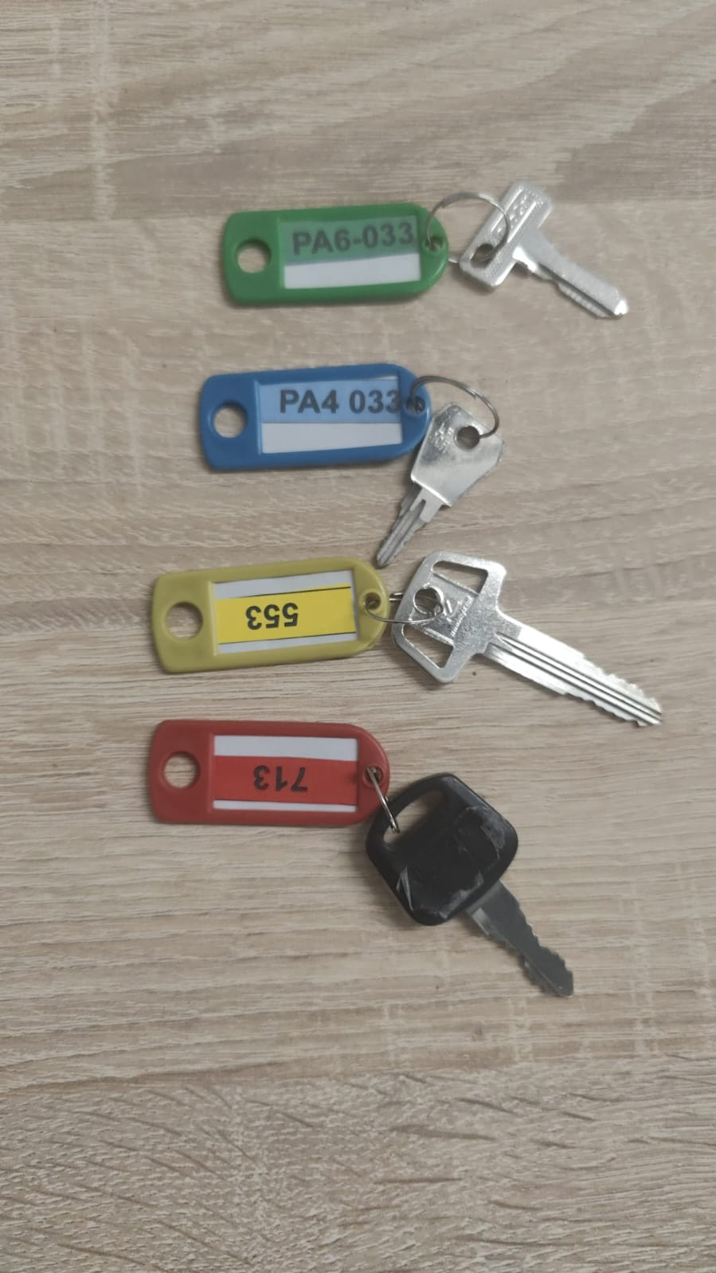

7.4 ABS GC Fleet list database record
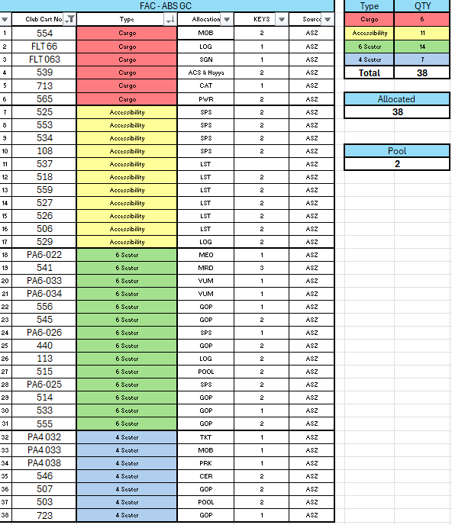

7.5 GCMS Mobile login interface

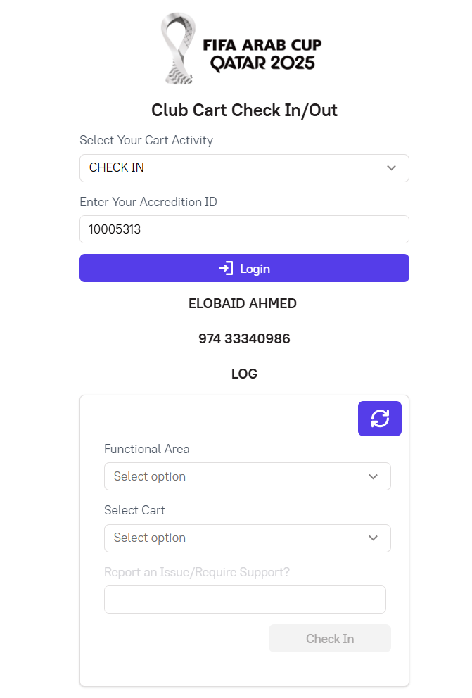
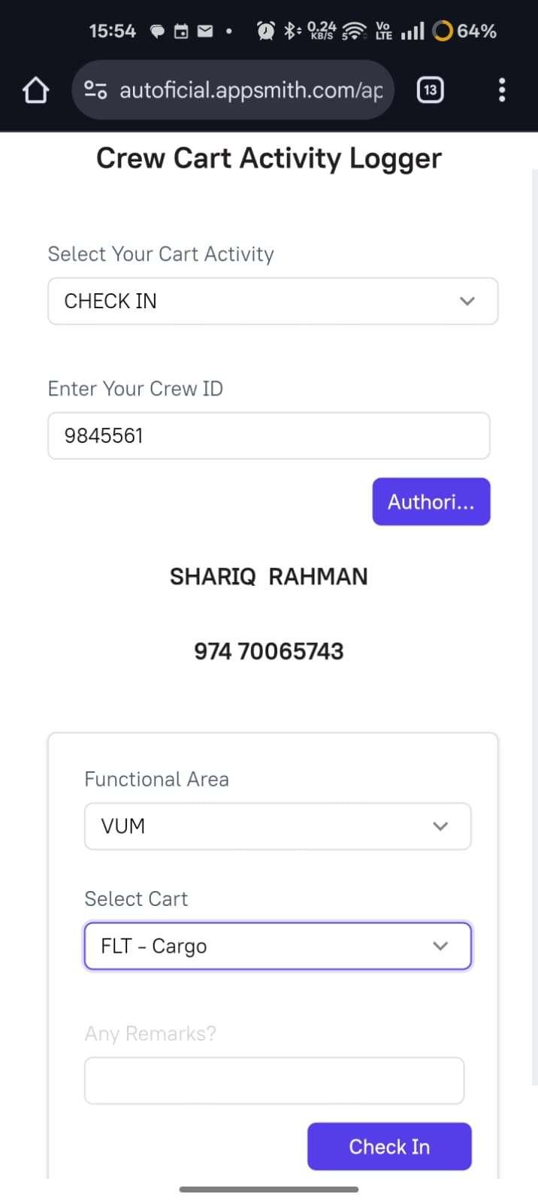
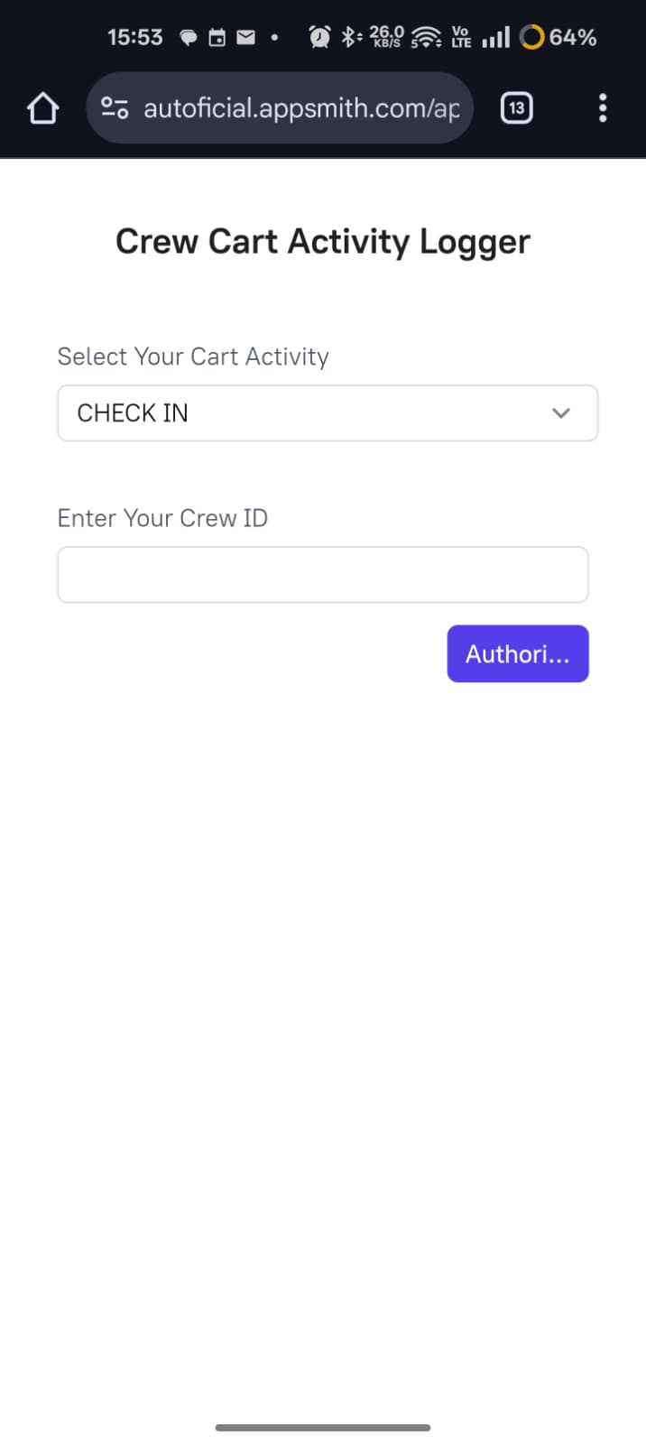

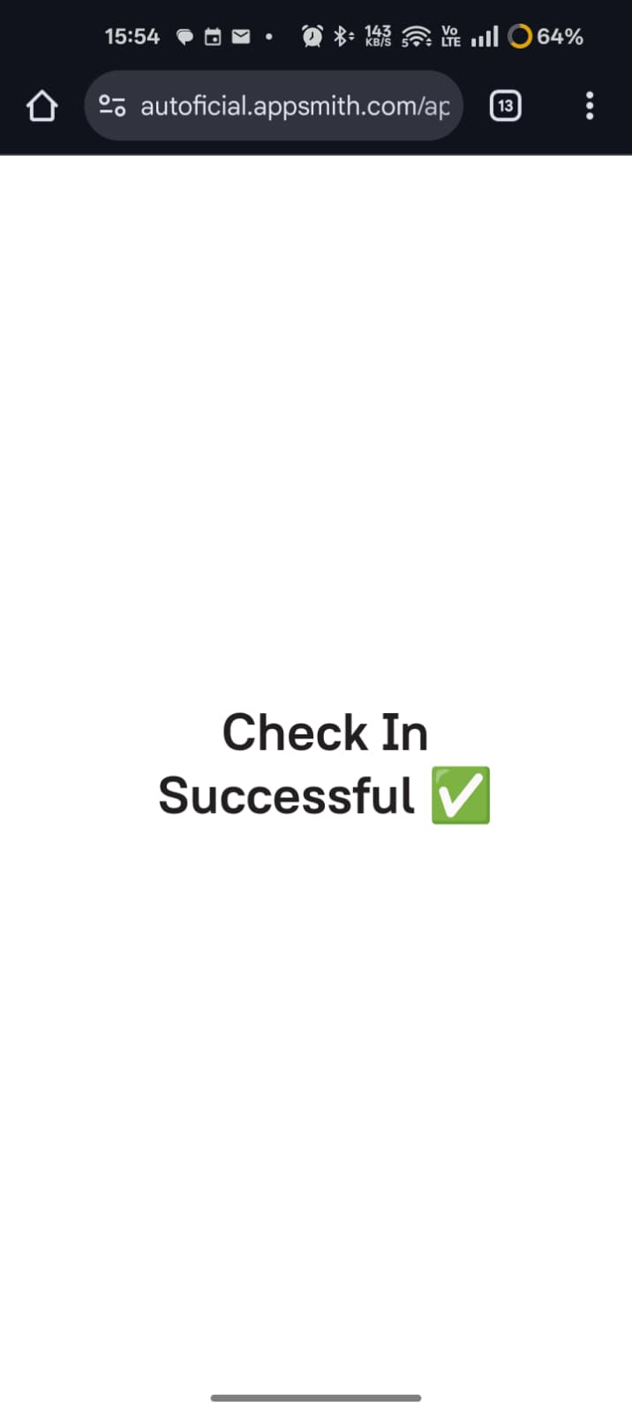
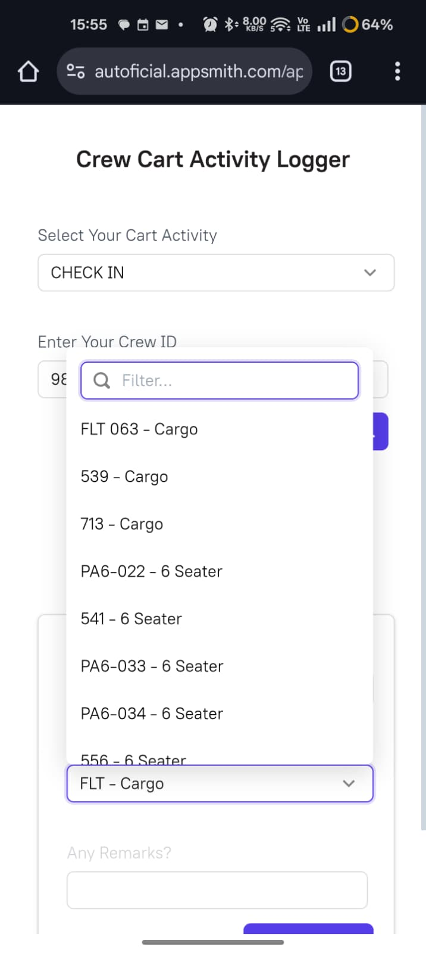

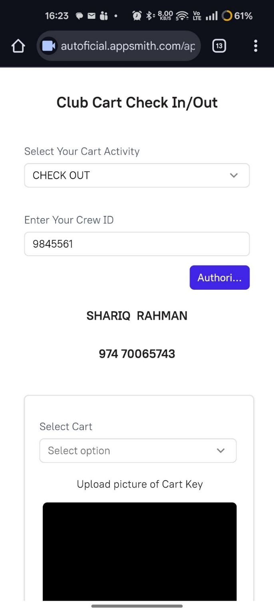
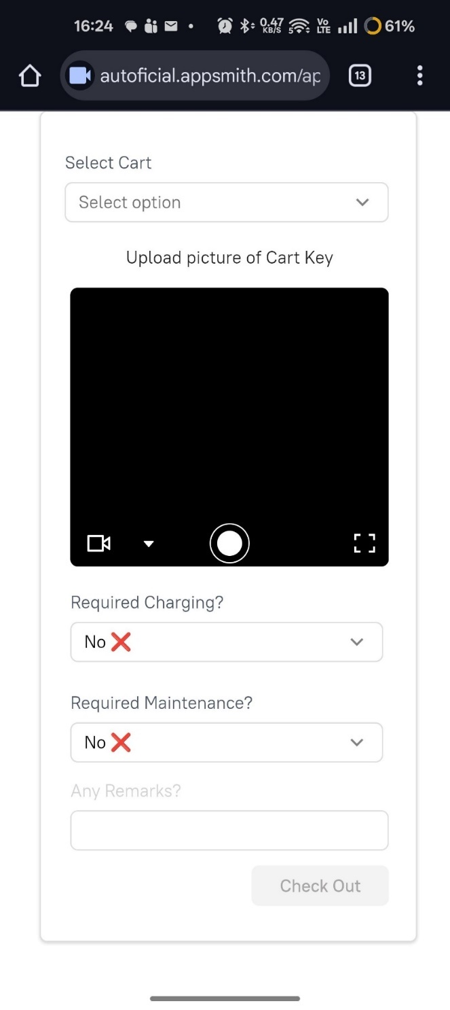

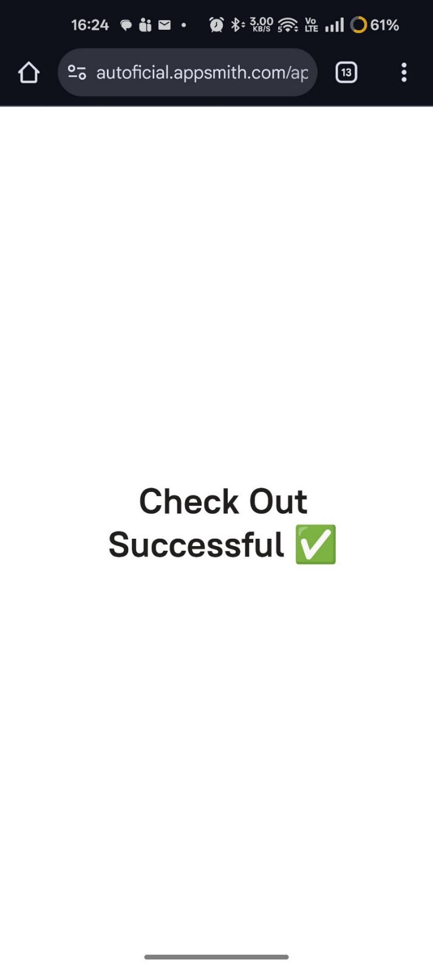

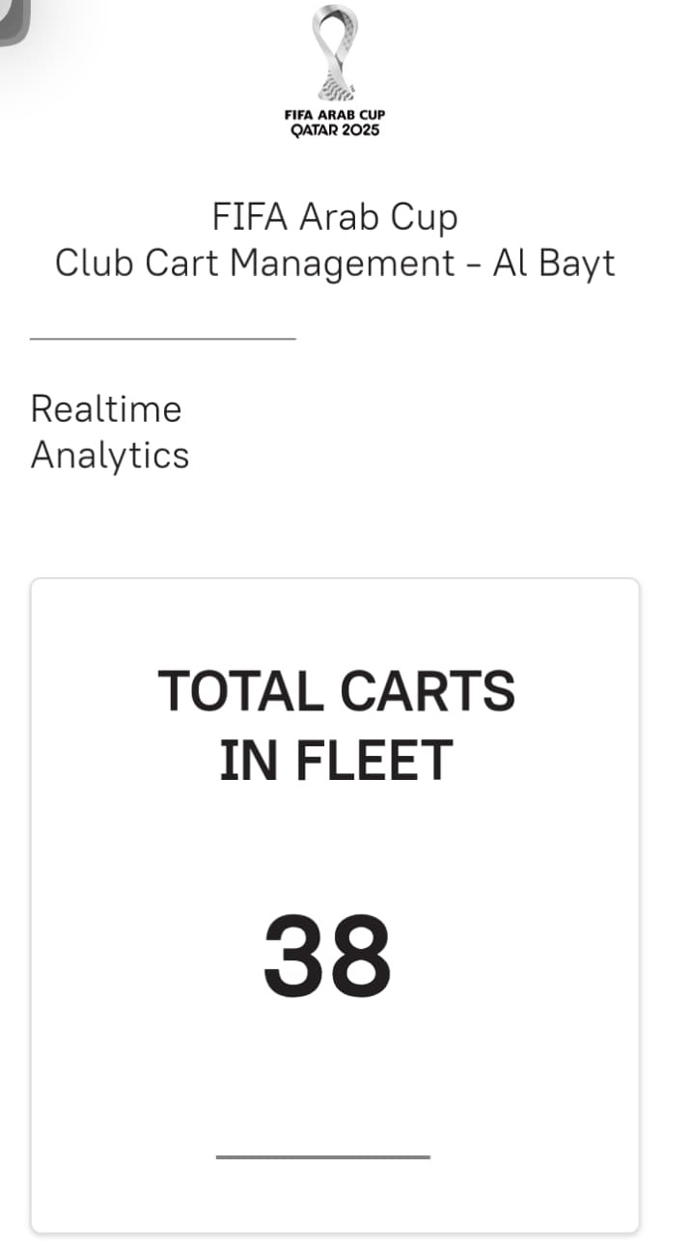
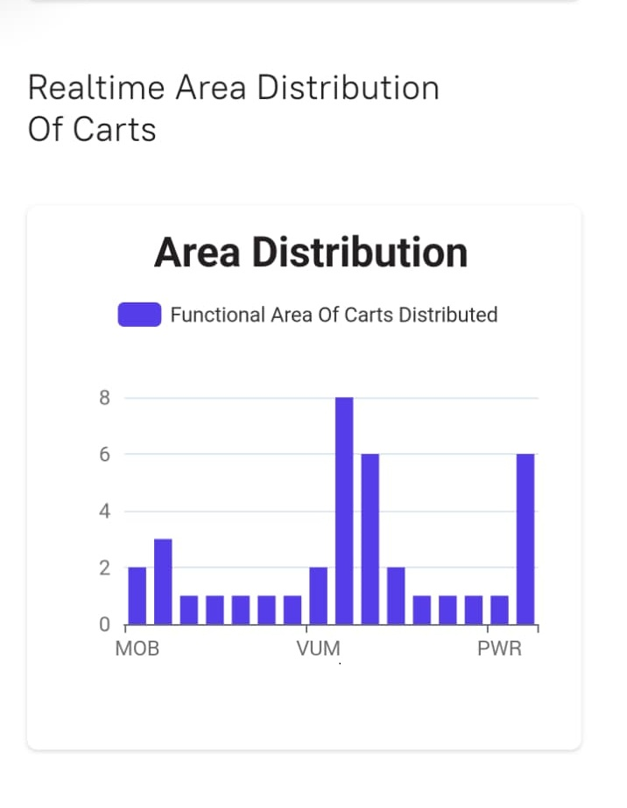
7.6 Admin panel & Reporting

